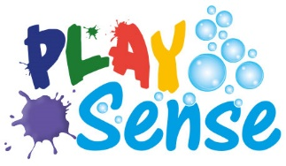

Sensory Art with Denice Stirling
Tin Foil and Rough Surfaces

Watch Denice’s 4 short workshops on making Sensory Art with Tin Foil’ on our YouTube channel https://www.youtube.com/channel/UC0g69ZbOIcRNApkuLVHn7zQ?view_as=subscriber

- Take a piece of tin foil, hold it up, shake it listen to the sound you are making. Hit it with a spoon while someone holds it.
- Wrap it around a cushion. Press the cushion with your fingers, lay your head on the cushion, listen.
- Scrunch it up, make a shape with it, make a sculpture
- Wrap it around your hand/foot
- Make a hat with it
- Wrap it over an object
- Use it to emboss. Hold it over a texture and rub with your fingers
- Use it to paint on, lay paper over the top and take a print
- Scrunch it up and print with it
- Stick down coloured tissue, sequins, buttons to make a collage
- Make a ‘stained glass’ picture with tinfoil and ‘sharpies’

Materials
- A roll of tinfoil
- Paint
- Glue
- Sequins & glitter
- Stickers
- Feathers
- Buttons
- Use fingers/brush/spreader to apply paint/glue
- Sharpies

